

T1560**(E)**(A6)T

**APRIL EXAMINATION NATIONAL CERTIFICATE**

# **STRENGTH OF MATERIALS AND SRUCTURES N5**

(8060065)

## 6 April 2016 (X-Paper) 09:00–12:00

### REQUIREMENTS: Hot-rolled structural steel sections BOE8/2

**Calculators may be used.**

**This question paper consists of 7 pages and 1 formula sheet of 2 pages.**

## DEPARTMENT OF HIGHER EDUCATION AND TRAINING REPUBLIC OF SOUTH AFRICA

NATIONAL CERTIFICATE

STRENGTH OF MATERIALS AND STRUCTURES N5

TIME: 3 HOURS

MARKS: 100

### INSTRUCTIONS AND INFORMATION

1. Answer ALL the questions.

1. Read ALL the questions carefully.

1. Number the answers according to the numbering system used in this question paper.

1. Write neatly and legibly.

### QUESTION 1

Sketch neatly a typical stress-strain graph for mild-steel in good proportions and

indicate on it the main important points. **[10]**

### QUESTION 2

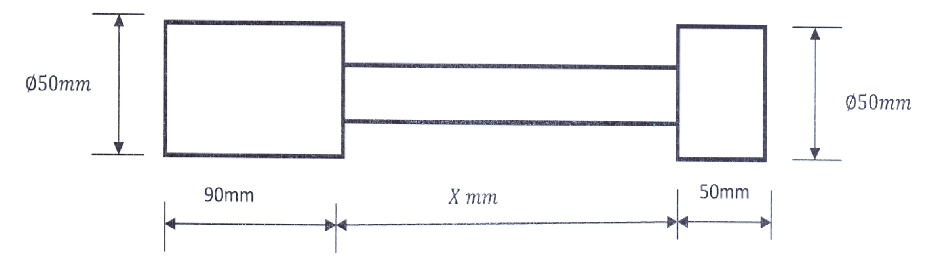

**FIGURE 1**

FIGURE 1, shows a rod subjected to a tensile load of 125 kN. The maximum tensile stress in the rod is 215 MPa. Take E as 210 GPa.

Calculate the following:

2.1 The diameter of the middle portion (2)

2.2 The length of the middle portion if the total extension is 0,29 mm. (6)

2.3 The extension of each portion (6)

2.4 The total strain energy absorbed by the rod (2)

### [16] QUESTION 3

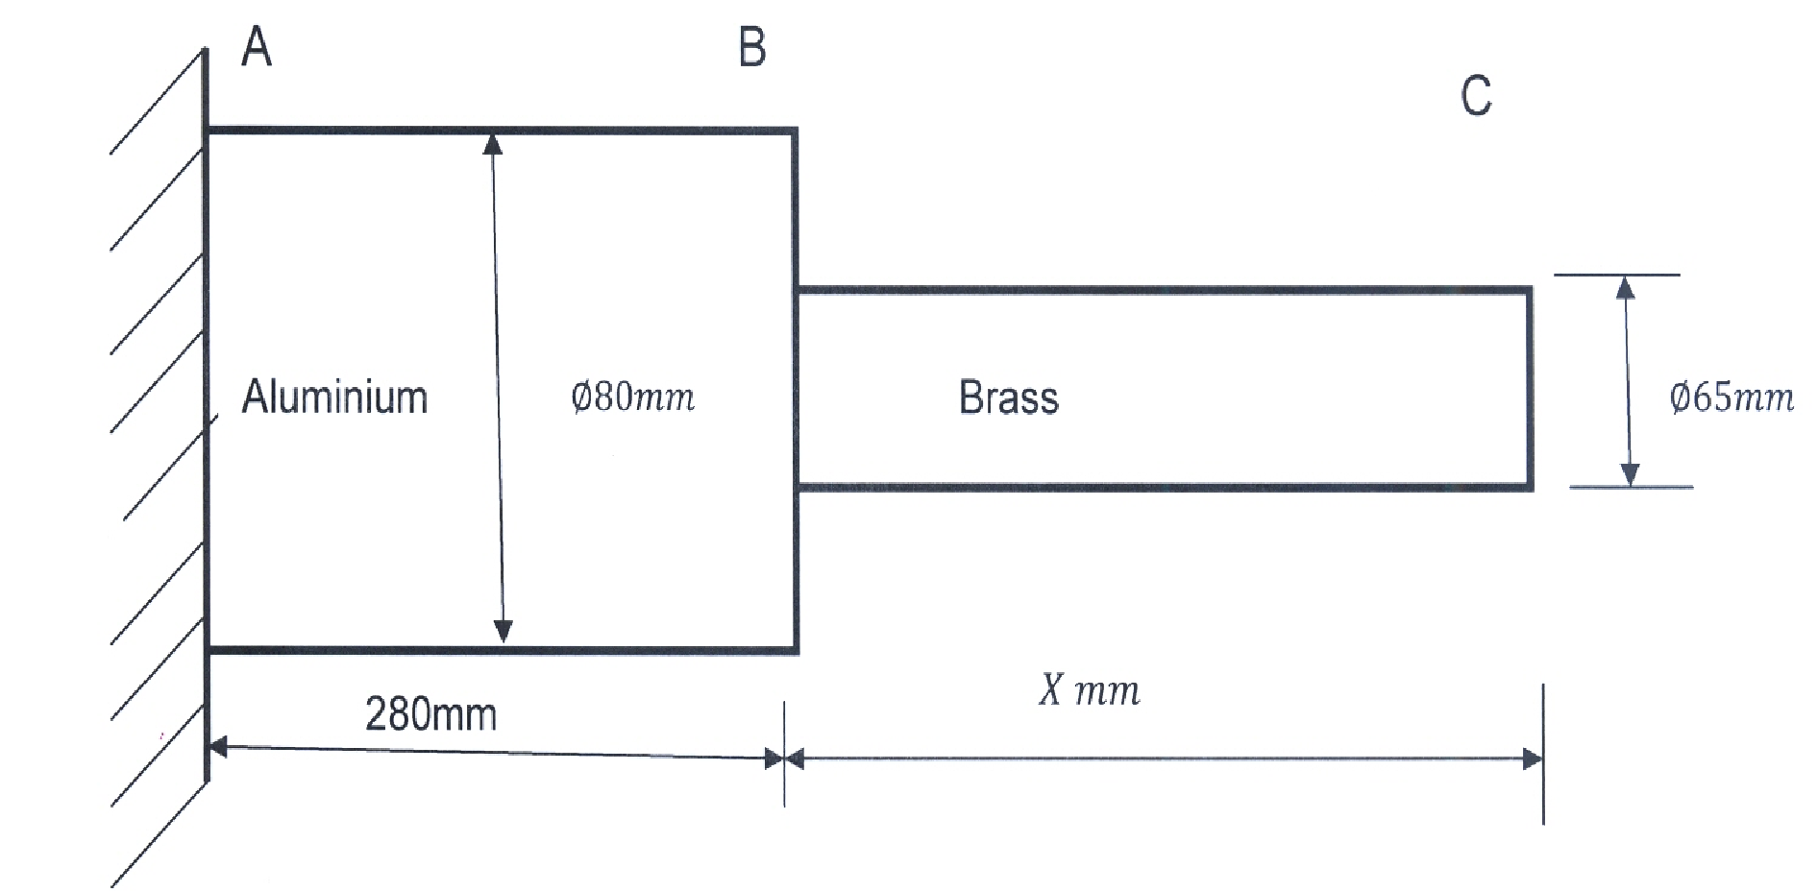

|  |  |
| --- | --- |
| **FIGURE 2** |  |
| A compound shaft ABC is as shown in FIGURE 2 and it is clamped at A. Portion AB is of aluminium material with a diameter of 80 mm and a length of 280 mm. Portion BC is of brass material with a diameter of 65 mm and unknown length. The shear stress for aluminium is 16 MPa and its modulus of rigidity is 30 GPa. The shear stress for brass is 27 MPa and the corresponding modulus of rigidity is 40 GPa.    Determine the following: |  |
| 3.1 The maximum torque that may be applied at point C for the compound shaft. | (5) |
| 3.2 The length of the brass portion in order to limit the total angle of twist to 0.56 . | (6)  **[11]** |

### QUESTION 4

A steel bar of 28 mm in diameter and 1.2 m long absorbs 68J of energy at its limit of proportionality under axial loading conditions. The Young's modulus for steel is 200 GPa.

Calculate the following:

4.1 The stress induced in the bar. (3)

4.2 The load when gradually applied. (2)

4.3 The load when suddenly applied. (2)

4.4 The load when it is dropped through a height of 130 mm. (5)

**[12]**

### QUESTION 5

A compound bar consists of a solid steel rod with a cross-sectional area of 2.5 cm2 and a copper tube with a cross-sectional area of 735 m2. The steel rod fits inside the copper tube and they are both fixed at their ends so that they have the same length all the time. Initially they are both of the length of 80 cm at 30 °C. The temperature of the compound bar is then raised by 80°C whilst their lengths are kept the same. ES = 210 GPa, αs = 12 × 10-6/°C, EC = 100 GPa and αc = 18 × 10-6/°C

Calculate the following:

5.1 The magnitude and nature of stresses induced by the temperature change. (7)

5.2 The resultant stresses when an external axial tensile force of 40 kN is applied

in addition to the temperature change. (8)

**[15]**

### QUESTION 6

A steel pipe is used to convey oil between two points. The pipe can be assumed to be simply supported at its ends with a span of 15 m. The density of oil is 880 kg/m3 and that of steel is 7 850 kg/m3.Stress in the pipe is limited to 90 MPa.

Calculate the dimensions of the pipe given that the diameter ratio is 1.05 : 1. **[10] QUESTION 7**

A thin cylindrical pipe with a diameter of 300 mm and a thickness of 6 mm is closed at its ends with plates of the same material and thickness as the pipe. It is then subjected to an internal pressure of 5,5 MPa.

Calculate the following:

7.1 The circumferential and longitudinal stresses induced. (4)

7.2 The compressive load required to reduce the longitudinal stress to zero. (2)

**[6]**

### QUESTION 8

A straight bar of steel 1.5 m long and 30 mm by 7 mm in section is mounted in a testing machine and loaded axially in compression till it buckles.

Make use of Euler formula E = 200 GPa.

Calculate the following:

8.1 The critical load when both ends are hinged. (4)

8.2 The critical load when one end is pinned and the other fixed. (2)

8.3 The critical load when both ends are fixed. (2)

**[8]**

-7-

### QUESTION 9

Graphically determine the magnitude and nature of forces in each member of the frame work shown in FIGURE 3.

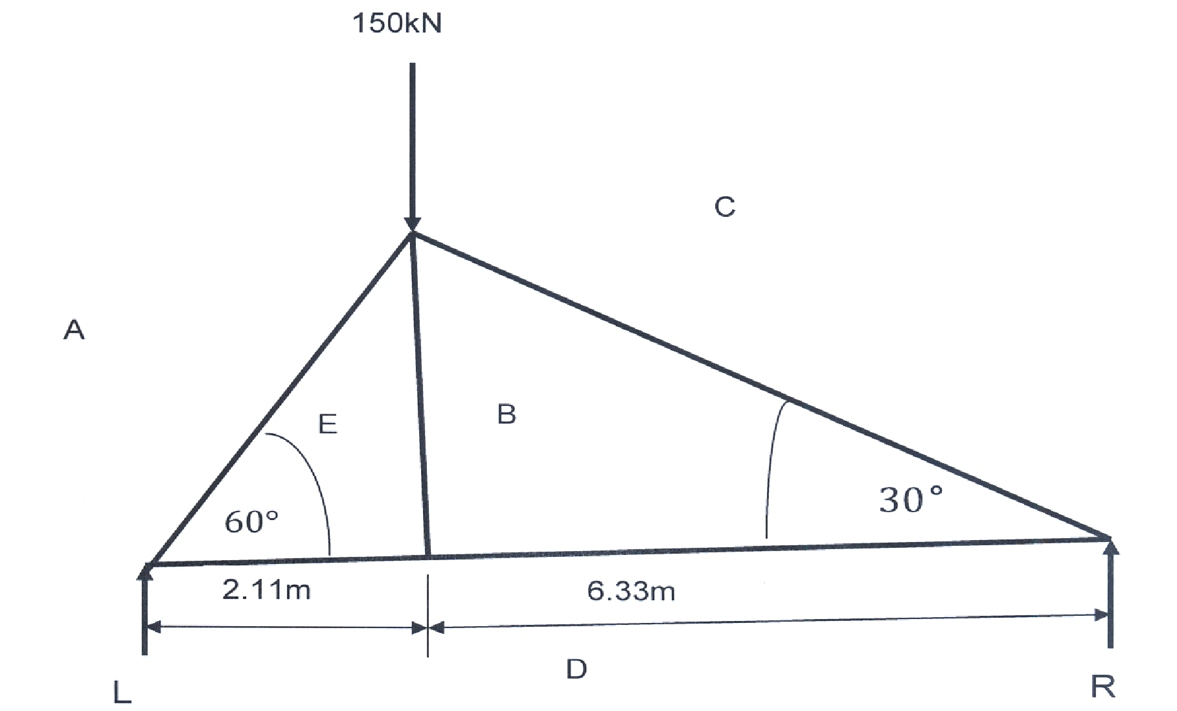

**FIGURE 3**  **[12]**

**TOTAL: 100**

-8-

### STRENGTH OF MATERIALS AND STRUCTURES N5

Any applicable equation or formula may be used.

s= *F*

*A*

#### Î= *X*

*L*

*E*= *FL*

*Ax*

*F*ççæ *A*11*E* + *A*12*E* ö÷÷ø= D*t*(a2 -a1) è

*F*ççèæ *AL*11*E* + *AL*22*E* ö÷÷ø= *L*1a1D*t* + *L*2a2D*t*

*U* = *Fx*

*F*2*L*

*U* =

2*AE*

*ac*

*b*

*b*

4

2

-

±

-

*x*=

2*a*

*F*2*L mg*(*h*+c) =

##### 2AE

*T* t *G*q

= = *J r L*

p(*D*4 -*d*4)

*J* =

32

p (*D*4 -*d*4)

*T* = t

16 *D*

p 3 *T* = t*D*

16 q= 10,2 *TL*4

# GD

q=*G*(10*D*,42-*TLd*4)

*P*=2p*NT*

*M* s *E*

= = *I Y R*  *M* =*WL* 8

*M* =w*L*2

8

# M =WL4

*Z* = *I* *y*

*M* =s*Z*

p 4 - *d*4) *I* = (*D*

64

*I* = p 4

*D*

64

*bd*3

*Ixx* =

12 p2*EI*

*F* = 2

## *Le*

s*A*

*F* = 2

1+*a*æçè*Lke* ö÷ø

4p2*EI*

*F* = 2

*L* s*A*

*F* = 2

1+ *a*æç*L*ö÷

*k* =

*Le*

*S* . *v*= ; *S* . *R*= *k k*

4

ø

è

*k*

*A*

*I*

*L*

*e*

Hinged ends *Le* =*L*

Fixed ends *Le* = *L*

2

One end fixed, one end hinged *Le* = *L*

2

Please turn over -9-

One end fixed, one end free *Le* =2*L*

s= *PD*

2 . *t*h

s= *PD*

4 *t*h

h= (*p* - *d*) *t*s*t* ´100

*pt*s*t*

p*d*2 *n*t

h= 4 ´100

*pt*s*t*

h= *ndt*s*c* ´100

*pt*s*t*

p*d*2 s*t*(*p* - *d*) *t* = *nt*

4

(*p* - *d*) *t*s*t* = *dtn*s*c*

Please turn over